|  |  |
| --- | --- |
| POE PART1 Project Proposal  Small Business [School Transport by Bra Nox] | WEDE5020  Olebogeng Mmalegoso Letlape  St10465556 Group2 |

Table of Contents

Research and planning 2

Introduction and background 3

History 3

Mission and vision statements 4

Target audience and goals 5

Functional Features: 6

Wireframes 7

Wireframes 8

Design and User Experience 9

Timeline and Milestones 9

Budget 11

Bibliography 12

# Research and planning

**Business type**: Local Primary school transport

**Owner:** Norman Dan Letlape well known as Bra Nox & Mdala

# Introduction and background

*Bra Nox, whose full name is Norman Letlape, is a respected and well-known transport owner in his village and the surrounding areas. With over 35 years of experience behind the field of taxi association, he has earned a strong reputation not only as a reliable driver but as a pillar of his community. Starting out as a taxi driver transporting people to and from town, Bra Nox has always had a deep passion for public transport and the important role it plays in people’s lives.*

# History

*His journey into school transport began when he noticed a recurring problem in his community: the lack of dependable, child-friendly school transport services. Many parents expressed concerns about their children’s safety and punctuality when using existing transport options. Rather than stand by, Bra Nox took initiative. Driven by compassion and a strong sense of community responsibility, he decided to start a school transport service that parents could trust. What began as a small operation soon grew into a lifeline for dozens of families in the area.*

*Bra Nox is known for his punctuality, discipline, and deep love for children. He treats each child on his transport as if they were his own, ensuring they are picked up on time, dropped off safely, and treated with kindness and respect. His calm demeanor and friendly attitude have made him a favorite among learners and parents alike. For him, transporting children isn’t just a job—it’s a calling.*

*He believes that building a strong, supportive community starts with taking care of the youngest members, and he lives out that belief every day. One-vehicle operation, the service has steadily grown to become a trusted primary school transport.*

# Mission and vision statements

***Mission:*** *To provide safe, reliable, affordable and punctual school transport for children in his community and also to give parents peace of mind and knowing their children are in trustworthy hands.*

***Vision:*** *To be a dependable and affordable school transport in the community and surrounding areas. He aims to expand his service while maintaining the highest standards of safety, care, punctuality and also creating jobs for unemployed youth in his community and also to be recognized for our commitment to child safety, community development and operational excellence.*



# Target audience and goals

***Target audience:*** *His community and surrounding areas that are specifically near the following schools*

* *Lerutlhware Primary*
* *Shalom Christian school*
* *Tsunyane primary school*
* *Reclief English medium school*

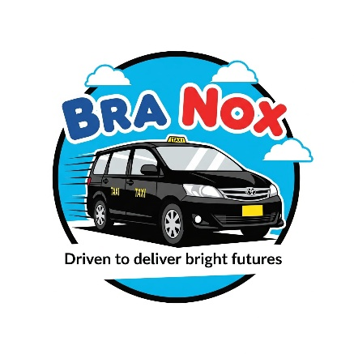

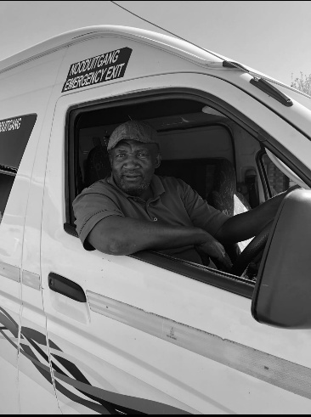

***Mode of transport:*** *Taxi [15 seaters]*

***Business Goals:*** *To transport all the primary kids from my village and buy more taxis so that it can accommodate every child and hire at least 5 drivers.*

* *Provide good service delivery to my clients [parents and kids]*
* *Grow big with my business to help out unfortunate families*

***Website Goals:*** *To provide updated information on routes, pricing and operating hours*

* *Establish a professional online presence for Bra Nox Primary School Transport.*
* *Build trust with new and existing clients through testimonials, safety policies, and driver profiles.*
* *Allow for easy contact through inquiry forms or WhatsApp integration.*

***Key Objectives:***

* *To increase community awareness and online visibility of the transport service.*
* *Offer clients (parents and guardians) easy access to service information from their electronic devices like smartphones and laptops.*
* *Provide a central hub for updates, news, and service announcements.*

***Key Performance Indicators:***

* *Number of contact form submissions or inquiries received.*
* *Number of monthly website visitors.*
* *Positive feedbacks or reviews collected through the site*

**Current Website Analysis***: Bra Nox business does not have any online presence*

**Proposed Website Features and Functionality: Essential Website pages are as follows**

1. **Home page:** Welcome users with core message, mission and why parents should choose Bra Nox school Transport
2. **About us**: Shares background, history and experience of Bra Nox in the transport Industry.
3. **Services page:** Describe routes, pricing, vehicle safety andhow transport operates daily.
4. **Geographical area:** Show map and list of areas covered with embedded Google Map.
5. **Privacy & Safety Policy Page:** Inform parents of data protection, safety protocols, and policies.

### **Functional Features:**

* **Contact/Inquiry Form**
* **Responsive Design** (mobile & tablet friendly).
* **Clickable Phone Number & Email**.
* **Embedded Google Map**.
* **Dropdown section** for FAQs.
* **Simple logo and branding** for identity.

# Wireframes

**Note**: All the webpages have logo and links of 5 webpages and footer with copyright, my student number and Bra Nox primary school transport.

**Homepage Wireframe**

Home| About us| Services| Geographical area| Privacy policy & Safety Commitment

|

Logo

FOOTER with © Bra Nox Primary School Transport

Contact Info / Quick Links [Phone | Email | Social Media]

Why Choose Us? (Icons/List) - Safe Transport - Experienced Drivers - Affordable Rates - On-Time Pickup

Welcome Message

Brief intro about Bra Nox Transport

Header image for background

"Driven to deliver bright futures" #Your kid, My Kid

# Wireframes

**About us wireframe**

About Bra Nox

Mission & Vision Statements

Image[Story Text - 35 years experience - Trusted Driver]

**Services wireframe**

- List of Offered Routes

- Daily Schedule (Pickup / Drop-off Times) - Safety Features:

"Our Service”

**Geographical area**

"Areas We Operate In"

Names of covered schools/

And Google embedded map

**Privacy policy**

"Privacy Policy & Safety"

Form for Guardian Contact Details (Dropdown)

What info we collect

How it’s used

POPI Act compliance

Emergency protocols

# Design and User Experience

***Background colors: Azure, White and black***

***Bra Nox School Transport Slogan: “Driven to deliver bright futures”***

***Website: Bra Nox School Transport***

Bra

**Layout: Header, body and Footer are present. Visual hierarchy used for heading fonts. Navigation of all 5 webpages. Responsiveness to be added for in part 2.**

**Colour Scheme: Headings (h1-h3)>Azure, white and black by default**

# Timeline and Milestones

**Programming languages: Part1 =HTML**

**Part 2=CSS**

**Part 3 =JavaScript**

**Webpages of Bra Nox Website: Home page, About us, Services, Geographical area and Privacy policy & Safety commitment.**

**Design: Imagery> Background images. Branding: Logo and color scheme aligns. User Interface(UI): To be added in part 2 and 3.**

**Font choices: weight bold/Strong, type= sans-serif and style= family: Arial**

***Timeline = 3 weeks***

***Milestones as follows***

1. *Proposal document(Word): This took me 3 weeks*
2. *Development and creation of webpages took me 4 week*

* ***Home page = 2 days***
* ***About us = 5 days***
* ***Services = 7 days***
* ***Geographical area = 7days***
* ***Privacy policy & Safety commitment = 7days***

***I thought I’ll take 3 weeks to complete the website but I had miner errors that took me so long to fix.***

# Budget

**Website Development Budget- Bra Nox Primary School Transport**

|  |  |  |
| --- | --- | --- |
| **Category** | **Description** | **Cost(ZAR)** |
| **Domain Registration** | **.com** domain(**branoxtransport.com**) | **R100/annum** |
| **Web Hosting** | Basic **plan and reliable uptime** | **R600/annum** |
| **Website Design & Setup** | Basic **HTML pages** | **R1000** |
| **Logo Design** | Simple **custom logo** | **R500(once off)** |
| **Mobile Optimization** | Ensuring it **works on phones & tablets** | **R500 (once off)** |
| **Basic SEO Setup** | Adding **title, meta tags, Google search visibility** | **R500(once off)** |
| **Annual Maintenance** | Basic **updates, backups** and **support** | **R1000/annual** |

***Total Estimated Budget:***

***Initial Setup Cost(once-off): R2 500***

*(Website Design + Logo Design + Mobile Optimization + SEO Setup)*

***Ongoing Annual Costs (per year): R1 700***

*(Domain +Hosting +Maintenance)*

# Bibliography

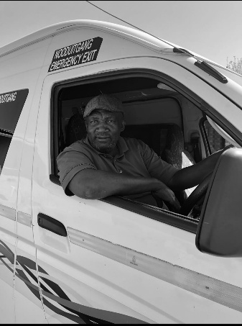

Figure 1Lesung, Rustenburg photograph by Olebogeng Letlape(source : Unsplash)

 Fig 2

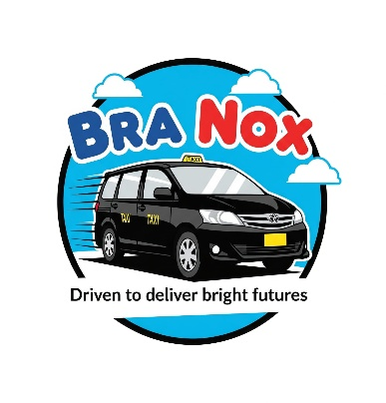 Fig 3

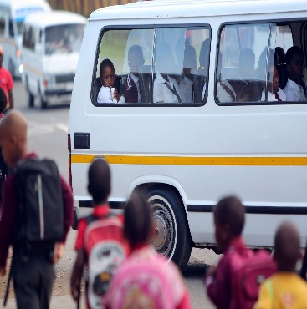 Fig 4

 Fig 5